Wednesday, 2 September 2026, postcard

The rest of the way to London

About 90 minutes from our destination, they came around offering breakfast. I took the smoked salmon option (over the egg-cheese-and-spinach choice) and got a warm bagel, scallion cream cheese, salmon, capers, pickled onions, tomato, cucumber, a sliced hard-boiled egg, and a lemon wedge. On the side, a bowl of vanilla Greek yogurt with fresh blueberries, strawberries, and kiwi slices, all sprinkled with granola, another generous serving of salted butter, and a little jar of raspberry jam.

As arranged, we were met in the jetway by a pair of wheelchairs, and a good thing, too, as the hike to passport control was, well, maybe not a mile, but pretty close! Partway there, we and the other wheelchair users were transferred to little six-passenger golf-cart-like vehicles for the rest of the trip. When we finally got there, the driver escorted us to a special spot where we could cut the long line and go through the automated, facial recognition booths—quick, easy, and we never even spoke to a person.

I watched closely for the nothing-to-declare line at customs, but we came to the exit before seeing anything resembling customs!

We made our way to the taxi queue, where we were promptly loaded into a good old-fashioned black London cab for the drive into town. About half-way there, we ran into a traffic slowdown, at which point our cabby warned us that 10 to 20 mph was about as fast as we could expect from there on. It was morning rush hour. Our hotel room wouldn't be ready for hours, so we just took advantage of the sightseeing. Between the drought and acid rain, the trees along the route were not looking happy.

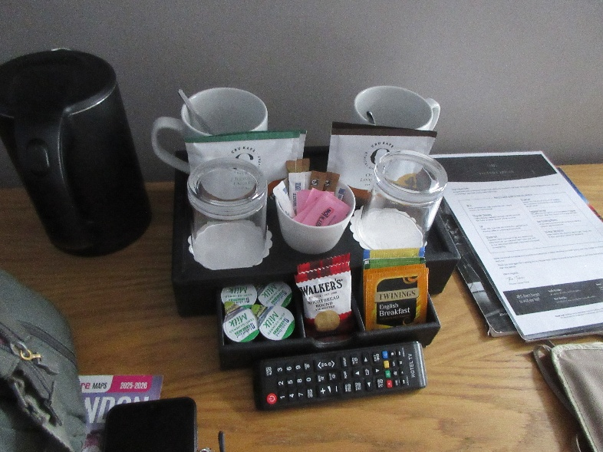
We had to walk the last few yards to our hotel, the Victory House, which is on a pedestrian street leading into all-pedestrian Leicester Square, epicenter of London theater. As predicted, our rooms weren't ready, and the earliest check-in was 2 pm—unless, of course, you paid the early-check-in-fee of £50, which we did, and were able to move into one room immediately.

Here's the coffee service in the room. Because this is England, we got a small electric kettle (the black object to the left of the cups), teabags, and "coffeebags" (i.e. bags you put in the cup and pour boiling water over like teabags). Because we're getting old, the first order of business was a nap.

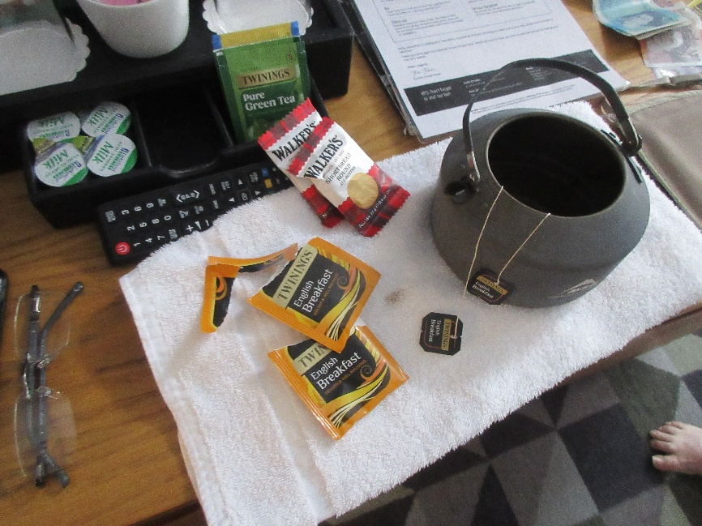
Even at noon, neither of us was hungry for lunch, and I had brought along my travel teapot, so we just made a pot of tea with the English Breakfast bags and ate the little shortbread cookies the hotel provided.

Thus fortified, we went out for an orientation walk around the neighborhood, prospecting for dinner. The possibilities are myriad.

Back at the hotel, we checked into the second room and could finally unpack, take showers, and otherwise settle in.

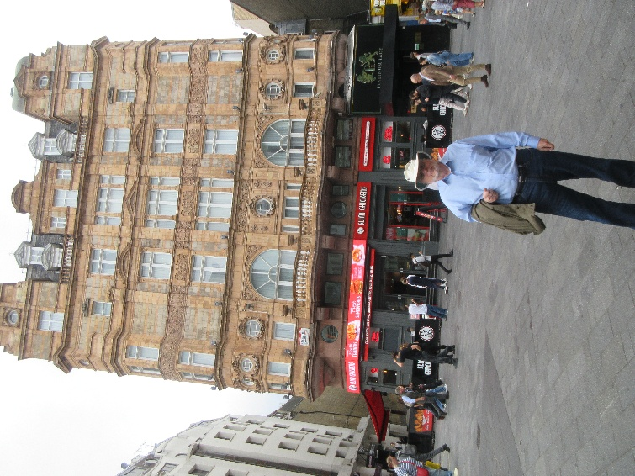
Here's a view of our hotel from Leicester Square. The entance is around the corner too the left. Our rooms are on the "first floor" (above the ground floor and the mezzanine floor), the row of windows above the businesses and the line of little balconies. Davids windows are the first two at the lower right, with the round portholes above them, and include the corner turret, so he has another window looking off to the right from the photo. My window is the right-hand arched one next to his. The little balcony in front of it is not intended to be occupied. It's floored with roofing materials, and the windows don't open anyway. In one corner of it are a rugby ball and a soccer ball—no idea why.
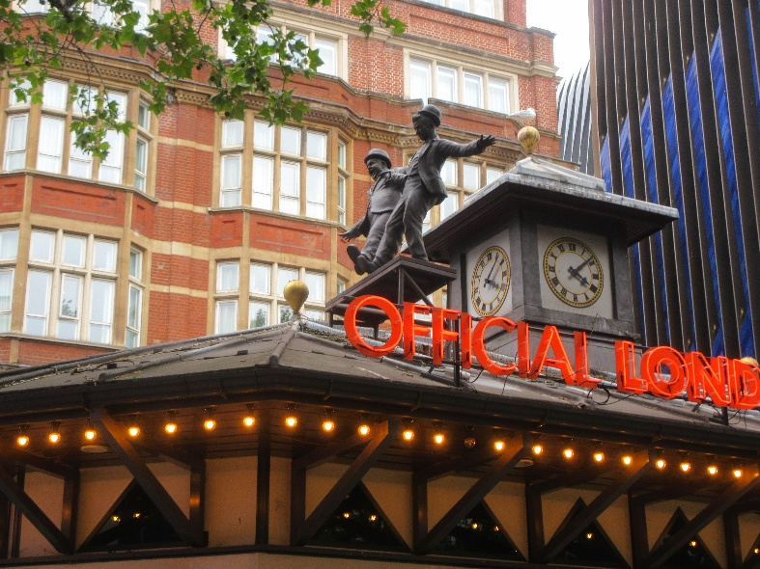
The square (actually more of a trapezoid) harbors a statue of Shakespeare in the center and, all around the edges, bronze statues of movie icons: Wonder Woman, Mr. Bean, Harry Potter, Shah Rukh Khan and Kajol in DDLJ, Mary Poppins, Bugs Bunny, Paddington, Daniel Kaluya in Get Out, Bridget Jones (clutching her diary). Here are Laurel and Hardy, cavorting atop the Official London Theatre Ticket Office

and Gene Kelly in Singin' in the Rain.

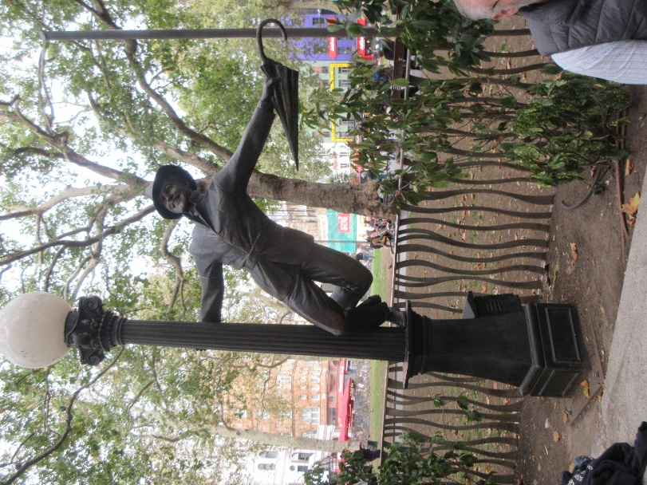
Batman lurks on the rooftop of the nearby Odeon Cineplex.

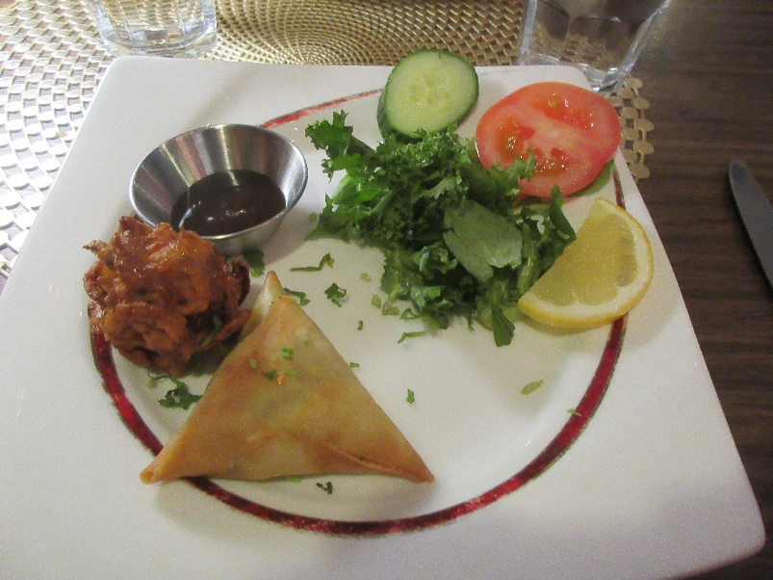
For dinner, we settled on Maharaja, on Charing Cross Road. For simplicity, we just opted for the "Deluxe Dish" for two, at which point, the waiters just paved the table with dishes.

For starters, we got onion baji and a spicy potato samosa, with tamarind chutney.

Then came tandoori chicken, lamb and chicken tikka, tandoori king prawn, salad, a vegetable curry, exceptionally puffy and crisp naan, and pulau rice—all yummy. We requested and got sweet mango chutney to round it all out. Wow.
